**Project Design Phase**

**Proposed Solution Template**

|  |  |
| --- | --- |
| Date |  |
| Team ID |  |
| Project Name |  |
| Maximum Marks |  |

**Proposed Solution Template:**

Project team shall fill the following information in the proposed solution template

|  |  |  |
| --- | --- | --- |
| **S.No.** | **Parameter** | **Description** |
| 1. | Problem Statement (Problem to be solved) |  |
| 2. | Idea / Solution description |  |
| 3. | Novelty / Uniqueness |  |
| 4. | Social Impact / Customer Satisfaction |  |
| 5. | Business Model (Revenue Model) |  |
| 6. | Scalability of the Solution |  |

**2.2 Empathy Map Curves**

* **Empathy Map Canvas: Factory Worker / Operator**

“The produce must be of top quality before shipping.”

“Sorting manually is tiring and slow.”

“Technology should assist me, not replace me.”

“If the machine misclassifies, I’ll be blamed.”

“I want it to be easy to operate and maintain.”

**THINKS**

“Is this system reliable when running for long hours?”

“Will I need special training to use this?”

“What happens if the machine breaks down mid-shift?”

“Will this technology reduce my role or importance?”

* **DOES**
* Starts and monitors the sorting machine.
* Occasionally inspects fruits on the belt manually.
* Calls maintenance if errors occur.
* Logs reports about the sorting batch quality.
* Adjusts or stops the conveyor in emergencies.
* **FEELS**
* Hopeful that the system will reduce effort.
* Proud when produce is sorted well.
* Nervous about machine errors.
* Stressed during peak production periods.
* **PAINS**
* Misclassification leading to customer complaints.
* Learning curve for using new AI-based machines.
* Dependence on stable internet/power supply.
* Fear of being held responsible for machine faults.
* **GAINS**
* Higher productivity, less fatigue.
* Better produce quality reaching the market.
* Potential for skill development in AI tools.
* Recognition for managing advanced systems.
* **Roadmap for Smart Sorting Project**

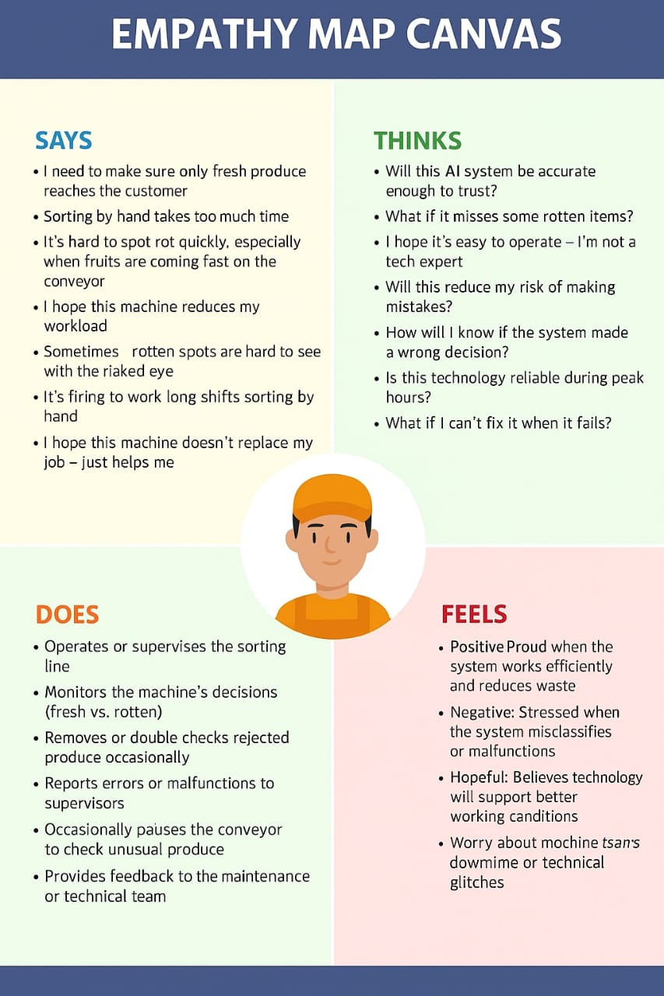

* **Phase 1: Problem Identification**
* Understand manual sorting challenges.
* Define quality criteria for fruits/vegetables.
* **Phase 2: Dataset Collection**
* Gather images of fresh/rotten produce.
* Annotate data for training.
* **Phase 3: Model Development**
* Choose a pre-trained model (e.g., MobileNet, ResNet).
* Apply transfer learning.
* Train and validate the model.
* **Phase 4: System Integration**
* Integrate AI model with robotic sorting arms or simulated environment.
* Set up conveyor + sensors + cameras.
* **Phase 5: Testing & Evaluation**
* Run test batches.
* Measure accuracy, precision, recall.
* Collect operator feedback.
* **Phase 6: Deployment**
* Full-scale use in production.
* Monitor performance and refine the model.
* **Phase 7: Future Enhancements**
* Add multi-class classification (e.g., ripeness levels).
* Predict shelf life using AI.